NON-REMOVABLE MILLE LACS BAND OF OJIBWE
IN THE COURT OF CENTRAL JURISDICTION

☐ District I | ☐ District II | ☐ District III

________________________________________  Petitioner.  v. | Case File No. _________________
________________________________________  Respondent. | APPLICATION FOR  FEE(S) WAIVER  (Informa Pauperis Affidavit)

- I am the Petitioner or Plaintiff in this case and declare that I am unable to pay the court fees and costs and I am entitled to the relief requested. In good faith, I request a court order waiving court fees and costs. I cannot support myself and my family and also pay or give security for costs.
- I believe that I have valid reasons for pursuing this action. My pleading(s) (the Petition, Complaint, Answer, Appeal, or other pleading) is/are attached.
- I am receiving public assistance under one or more of the following programs:
☐ | SSI (Supplemental Security Income) and/or MSA (Minnesota Supplemental Assistance Programs)
☐ | MFIP (Minnesota Family Investment Program) or TANF (Temporary Assistance for Needy Families)
☐ | SNAP (Supplemental Nutrition Assistance Program)
☐ | MinnesotaCare, Medical Assistance or General Assistance Medical Assistance
☐ | GA (General Assistance) or Discretionary Work Program
☐ | Energy Assistance Program
☐ | Another means-tested program (Name the program):  _______________________________________________________________

I have attached proof that I receive public assistance (such as a copy of an EBT card or a cancelled check from the agency, or I will provide proof if the Judge requests it.

If you checked any of the boxes listed above in #3, go directly to the signature line on page 4.
- ☐ I am represented in this matter by attorney ____________________________________ from (Attorney’s Name)
☐ Mille Lacs Band Member Legal Aid or ☐ another civil legal services program or volunteer attorney based on indigency. If you are represented by a legal aid attorney, go directly to the signature line on page 4.

- My family size is ______ persons (include yourself, your spouse or partner, your minor children and other dependents in your household). The following persons reside in my household:
Name | Age | Relationship to You

- ☐ My gross ANNUAL income before taxes and deductions is $ __________________, which is less than 125% of the Federal Poverty Level for my family size of __________ members. I have attached proof of my family income (such as an income tax return) or I will provide proof if requested by the Court.

If you did not check #3, 4, or 6 above, you MUST complete the remaining questions.

- My gross MONTHLY income before taxes and deductions is $ _______________. My net (take home) monthly income is $ _______________, and the source of that income is:
☐ Wages ☐ Unemployment ☐ Per Capita Payments ☐ Spousal Support ☐ Social Security
☐ Self-Employment Income ☐ Trust Income ☐ Child Support
☐ Other: _____________________________________________________________________

- I ☐ am ☐ am not married. If married, my spouse’s gross MONTHLY income before taxes and deductions is $ ______________. My spouse’s net (take home) monthly income is
$ _______________, and the source of that income is ______________________________; OR
☐ I do not know my spouse’s income because: ______________________________________
_____________________________________________________________________________.
- All other family members and dependents living with me have a net monthly income as follows:
Name | Age | Net (take home) Monthly Income | Source of Income
 |  | $
 |  | $
 |  | $

- I pay $ _______________ per month in court-ordered child support and/or court-ordered child care costs.
- I pay $ _______________ per month in court-ordered spousal support.
- I pay $ _______________ per month for ☐ rent ☐ mortgage payment.
- I own the following:
ASSET(S) |  |  | VALUE
Cash |  |  | $
Checking, savings and credit union accounts |  |  | $
Cars, boats and other vehicles:
Make and Model | Year | Unpaid Loan | $
 |  | $ | $
 |  | $
Real estate (market value minus unpaid mortgage/loans)
Homestead |  |  | $
Other real estate: |  |  | $
Other personal property (stock, bonds, jewelry, art, etc. – List separately.)
 |  |  | $
 |  |  | $
 |  |  | $
TOTAL ASSETS: |  |  | $

- I am presently have debt, excluding mortgage(s) and vehicle loans, totalling $ _______________.

- Other factors that support my request for a waiver of fees and costs are (explain unusual medical expenses, emergencies, reasons that the family’s money is not available to you, or other circumstances to help the Judge understand your situation):

VERIFICATION

I declare under penalty of perjury that everything I have stated in this Application for Fee(s) Waiver is true and correct.

Dated:
Petitioner’s Signature

Petitioner’s Printed Name

APPENDIX A

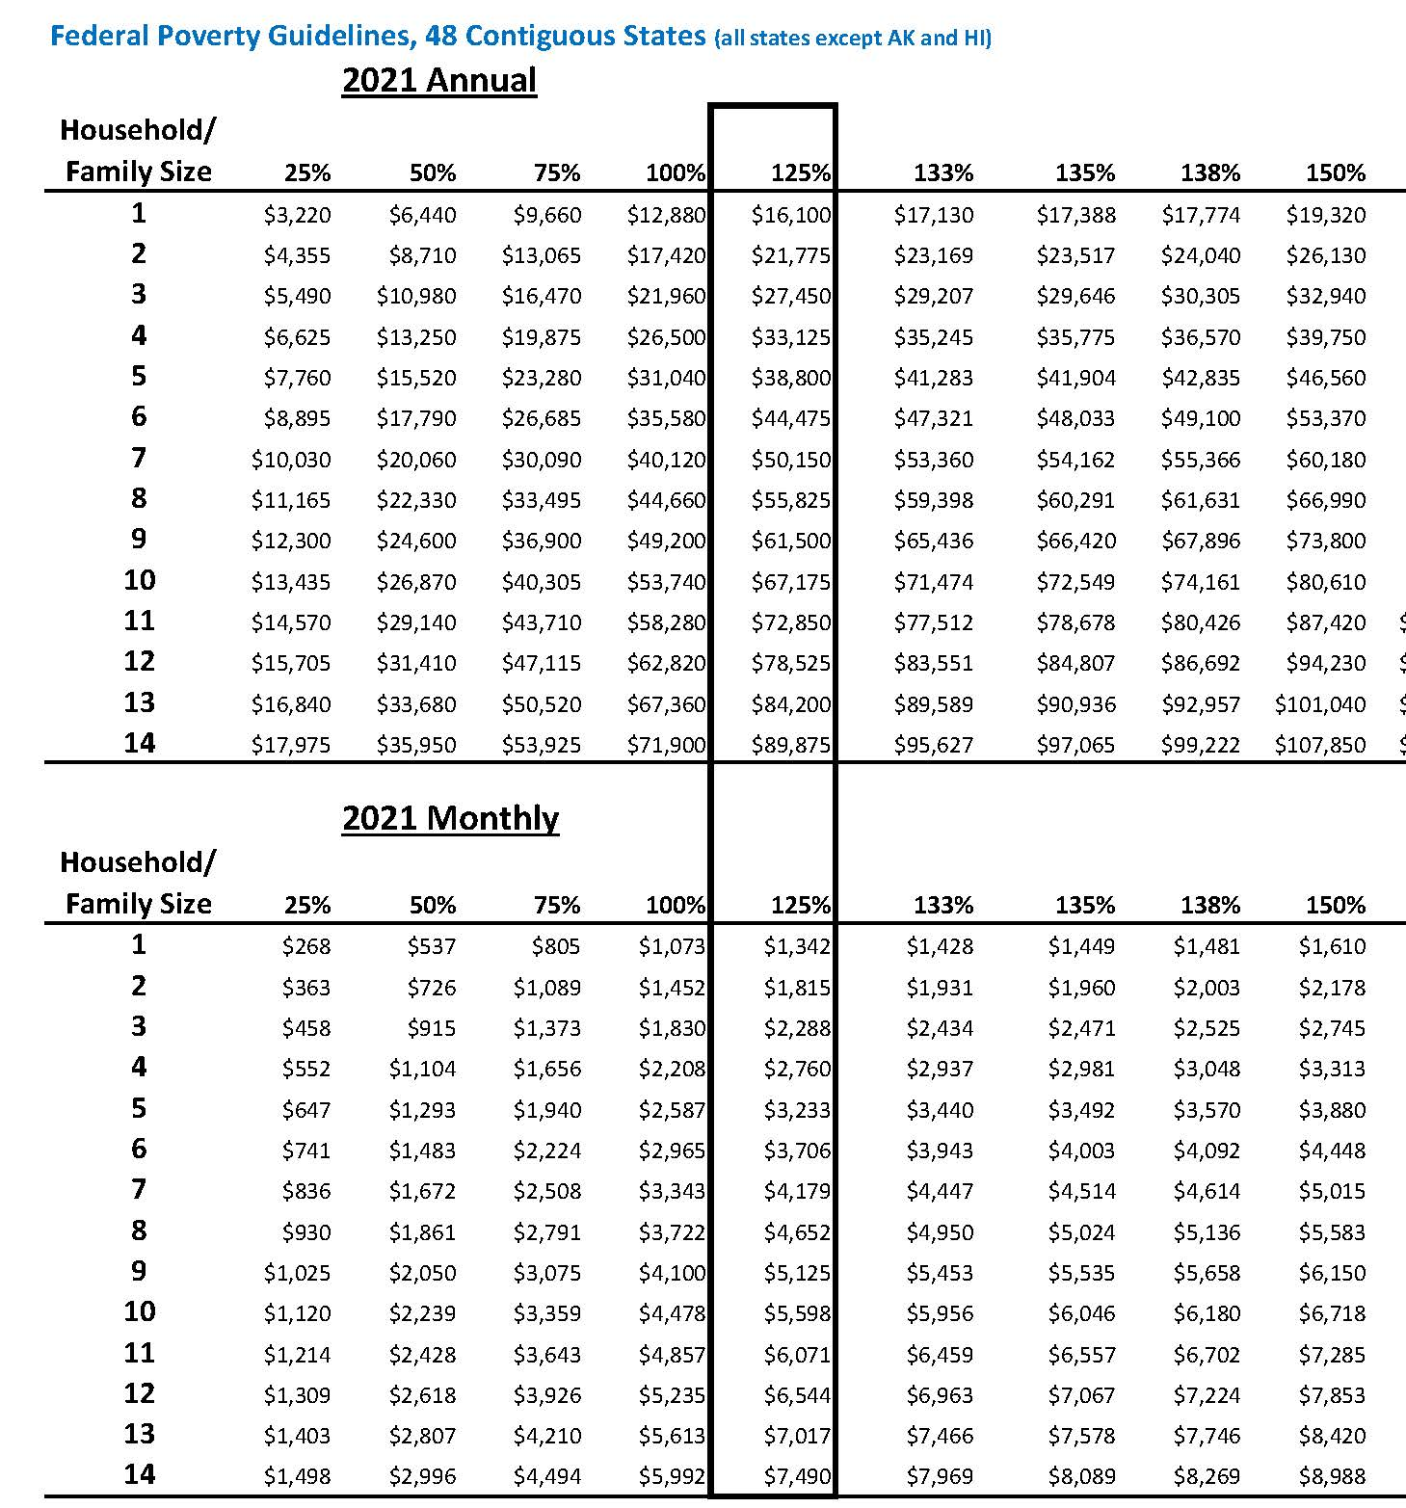

See Federal Poverty Level Guidelines attached as Appendix A.

